# Assignment 3: Clustering

These questions concern the main conformation of proteins. Part of a protein's main chain is shown in Figure 1. A protein chain is able to fold into its native conformation by rotation around two of the bonds in the main chain, designated  (phi) and  (psi). Some combinations of phi and psi are impossible (e.g. some atoms clash into each other if we try to force the main chain to have a particular combination of phi and psi). Some other combinations of phi and psi are very common since they are energetically favourable. To understand the problem domain better, please look at:

* <http://bioinformatics.org/molvis/phipsi/>
* <http://tinyurl.com/RamachandranPrincipleYouTube>

The provided data file contains a list of phi and psi combinations that have been observed in proteins. The angles are measured here in degrees.

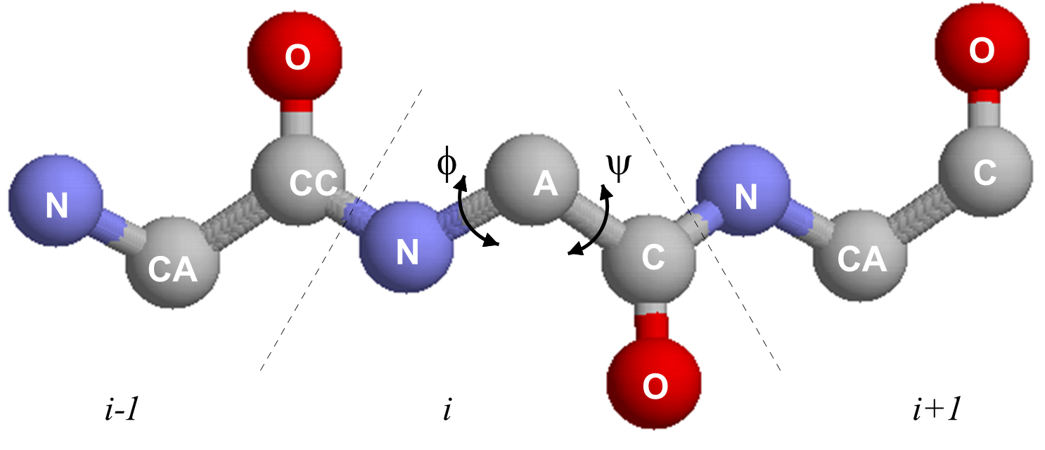

Figure 1. A protein's main chain. The heavy (i.e. non-hydrogen) main chain atoms of three consecutive amino acid residues (i-1, I and i+1) are represented by spheres, and the covalent bonds between these atoms are represented by rods. Nitrogen and oxygen atoms (N and O) are shown in blue and red respectively; carbon atoms are shown in grey. The central carbon atom (the alpha carbon, or C, labelled CA) is the main chain atom to which a side chain (not shown) is attached. Rotation can occur around the bonds labelled  (phi) and  (psi).

1. Show the distribution of phi and psi combinations using:
   1. A scatter plot (0.5p)
   2. A heatmap (0.5p)
2. Use the K-means clustering method to cluster the phi and psi angle combinations in the data file.
   1. Experiment with different values of K. Suggest an appropriate value of K for this task and motivate this choice. (1p)
   2. Validate the clusters that are found with the chosen value of K. Hint: See the slides for Lecture 6, Section Validating clustering. (1p)
   3. Do the clusters found in part (a) seem reasonable? (0.5p)
   4. Can you change (transform the represenation of) the data to get better results (or the same results in a simpler way)? This is a tricky question which requires some thinking and creativity. (Hint: since both phi and psi are periodic attributes, you can think of shifting/translating them by some value and then use the modulo operation.) (1.5p)
3. Use the DBSCAN method to cluster the phi and psi angle combinations in the data file.
   1. Motivate:
      1. the choice of the minimum number of samples in the neighbourhood for a point to be considered as a core point, and
      2. the choice of the maximum distance between two samples belonging to the same neighbourhood (“eps” or “epsilon”).

Highlight the clusters found using DBSCAN and any outliers in a scatter plot. How many outliers are found? Plot a bar chart to show which amino acid residue types are most frequently outliers. (2p)

* 1. Compare the clusters found by DBSCAN with those found using K-means. (0.5p)
  2. Discuss whether, in general, the clusters found using DBSCAN are robust to small changes in the minimum number of samples in the neighbourhood for a point to be considered as a core point, and/or the choice of the maximum distance between two samples belonging to the same neighbourhood (“eps” or “epsilon”). (0.5p)

1. The data file can be stratified by amino acid residue type. (2p)
   1. Use DBSCAN again to cluster the data that have residue type PRO. Investigate how the clusters found for amino acid residues of type PRO differ from the general clusters (i.e., the clusters that you get from DBSCAN with mixed residue types in question 3).
   2. Now use DBSCAN to cluster the data that have residue type GLY. Investigate how the clusters found for amino acid residues of type GLY differ from the general clusters.

Remember that when doing clustering using DBSCAN for a) and b) here, the parameters might have to be adjusted from those used in previous questions (and explain why).

## Submitting work

* All Python code written.
* A report that includes the figures produced and the descriptions/discussions that are requested in the questions. Remember to motivate all steps and decisions taken.

In each file that you submit, give the names of the people submitting the work. On the first page of the report state how many hours each person spent working on the assignment.

If you upload a zip file, please also upload any PDF files separately (so that they can be viewed more conveniently in Canvas).